Test Case: tc001_SPX_Dev5_Crear_Requisicion_Spot_Tipo_Cobro_CC
Step 1 - Enter username and password and click to button Enter : Credentials Entered
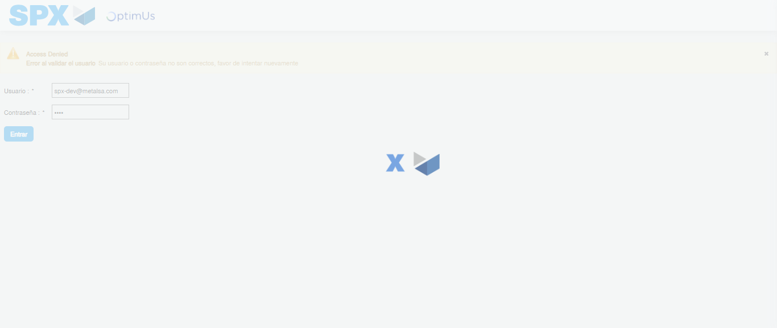Image file-name: QC_Testing-tc001_SPX_Dev5_Crear_Requisicion_Spot_Tipo_Cobro_CC-1783983749081

Step 2 - Select to UEN and Access to Spot Buy Requisitions : UEN Correctly selected and Correct access
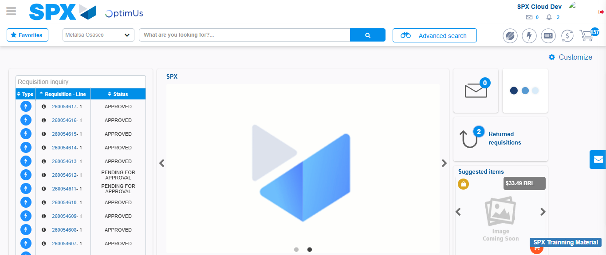Image file-name: QC_Testing-tc001_SPX_Dev5_Crear_Requisicion_Spot_Tipo_Cobro_CC-1783983775200

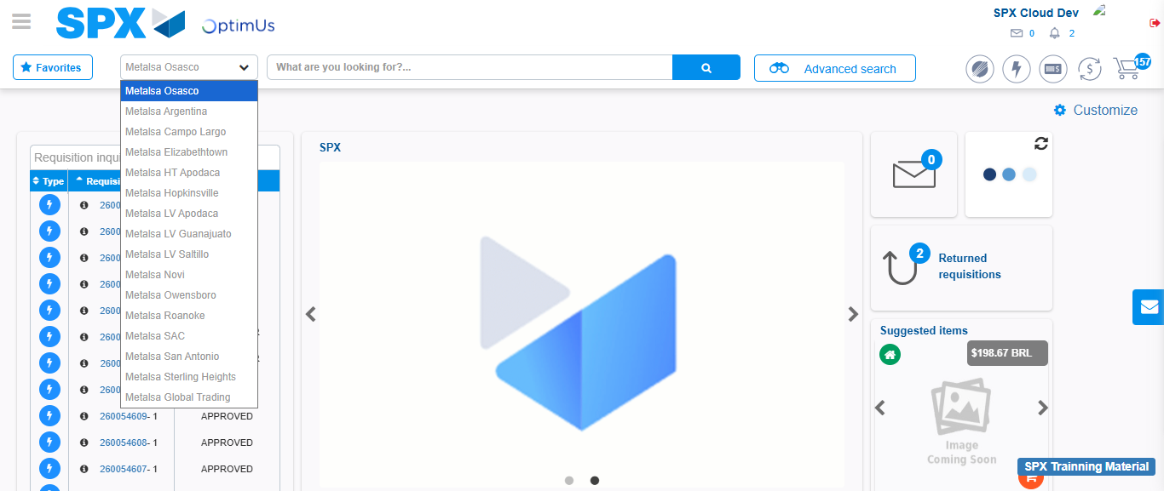Image file-name: QC_Testing-tc001_SPX_Dev5_Crear_Requisicion_Spot_Tipo_Cobro_CC-1783983777780

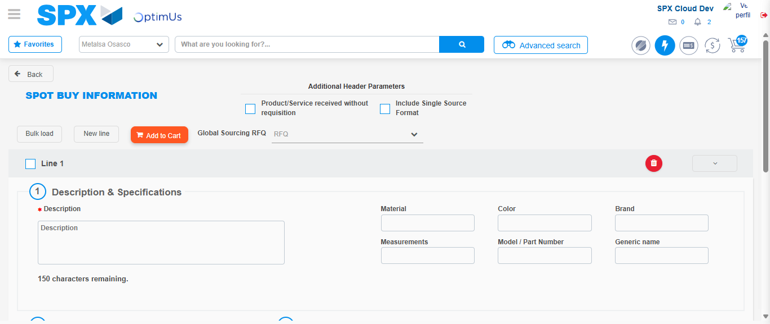Image file-name: QC_Testing-tc001_SPX_Dev5_Crear_Requisicion_Spot_Tipo_Cobro_CC-1783983799495

Step 3 - Data Capture Spot Buy Requisition : Data captured correctly
Image file-name: QC_Testing-tc001_SPX_Dev5_Crear_Requisicion_Spot_Tipo_Cobro_CC-1783983799773

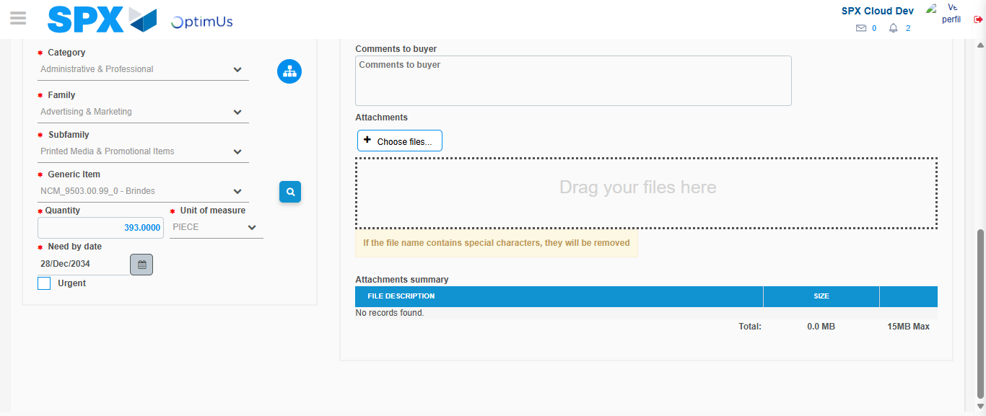Image file-name: QC_Testing-tc001_SPX_Dev5_Crear_Requisicion_Spot_Tipo_Cobro_CC-1783983812228

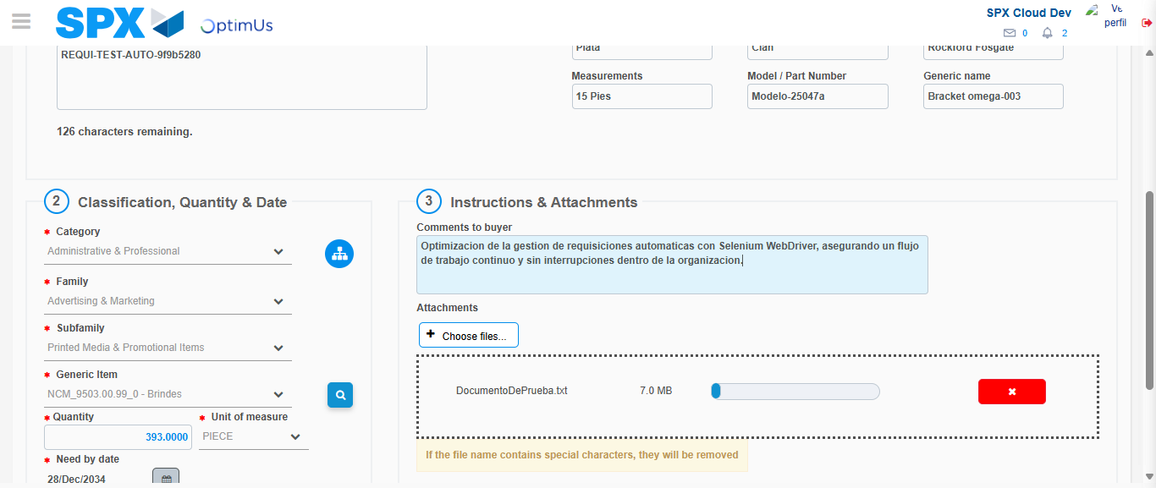Image file-name: QC_Testing-tc001_SPX_Dev5_Crear_Requisicion_Spot_Tipo_Cobro_CC-1783983813010

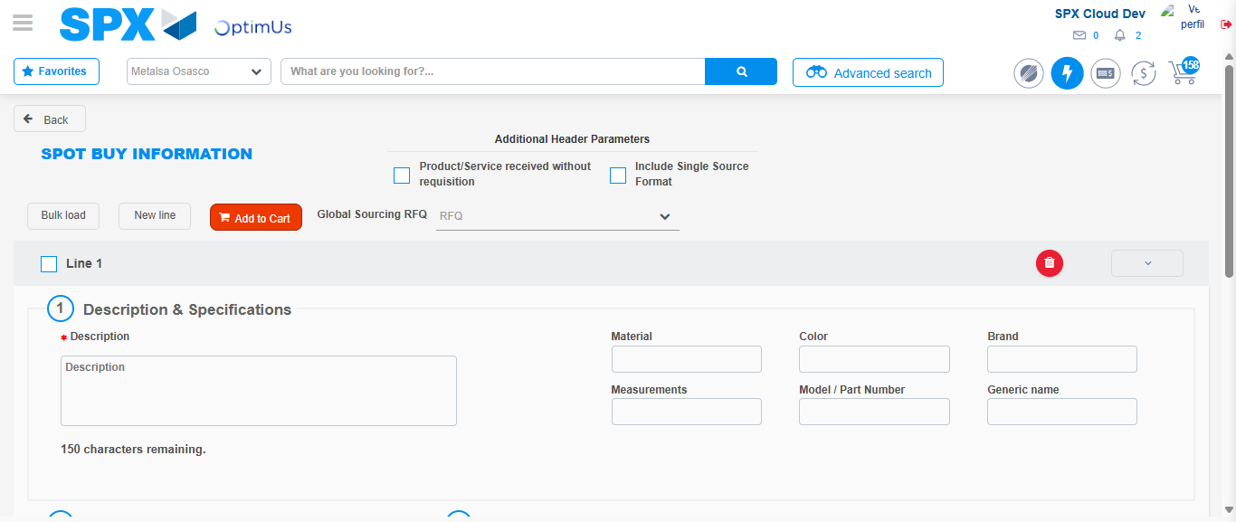Image file-name: QC_Testing-tc001_SPX_Dev5_Crear_Requisicion_Spot_Tipo_Cobro_CC-1783983827093

Step 7 - Return to Main Page SPX : Return to Main Page SPX
Image file-name: QC_Testing-tc001_SPX_Dev5_Crear_Requisicion_Spot_Tipo_Cobro_CC-1783983775200

Image file-name: QC_Testing-tc001_SPX_Dev5_Crear_Requisicion_Spot_Tipo_Cobro_CC-1783983777780

Image file-name: QC_Testing-tc001_SPX_Dev5_Crear_Requisicion_Spot_Tipo_Cobro_CC-1783983799495

Image file-name: QC_Testing-tc001_SPX_Dev5_Crear_Requisicion_Spot_Tipo_Cobro_CC-1783983829289

Image file-name: QC_Testing-tc001_SPX_Dev5_Crear_Requisicion_Spot_Tipo_Cobro_CC-1783983829448

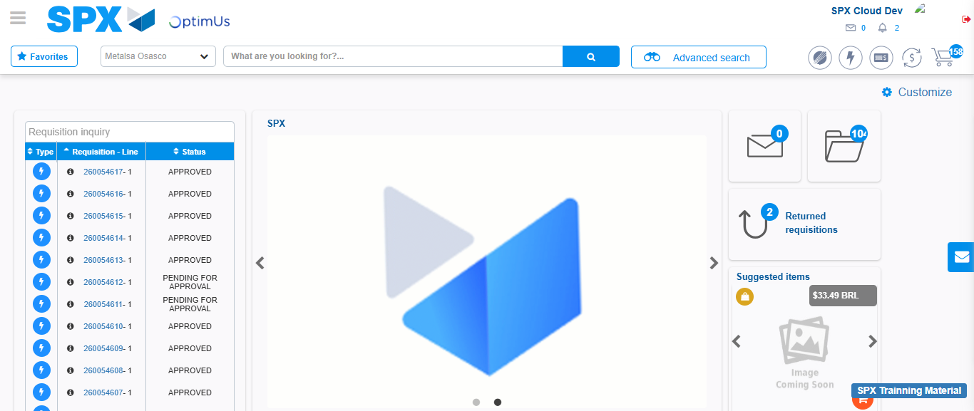Image file-name: QC_Testing-tc001_SPX_Dev5_Crear_Requisicion_Spot_Tipo_Cobro_CC-1783983850492

Step 8 - Log Out : Log Out SPX
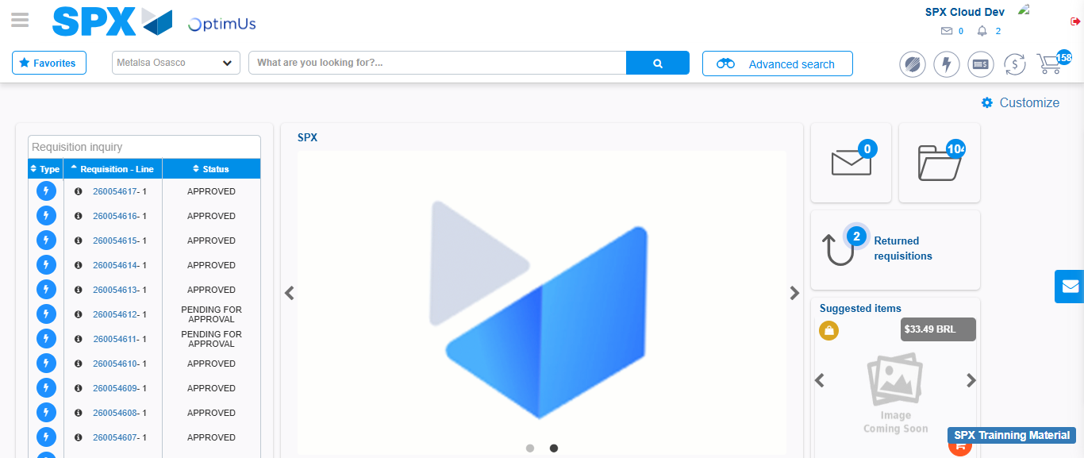Image file-name: QC_Testing-tc001_SPX_Dev5_Crear_Requisicion_Spot_Tipo_Cobro_CC-1783983850772

